**PhD PROPOSAL FOR THE DOCTORAL SCHOOL**

**« Ecologie, Géosciences, Agronomie, ALimentation »**

# **GENERAL INFORMATION**

|  |
| --- |
| **Thesis title: Modelling the biological control of legume pests by a community of natural enemies and application to the diversification of cropping systems from plot to landscape** |
| **Acronym:** MORAL |
| **Disciplinary field 1:** Ecology  **Disciplinary field 2:** Agronomy |
| **Three keywords**: pest control service, dispersion, pesticide-free systems |
| **Research unit : IGEPP** |
| **Name of the thesis director: PLANTEGENEST Manuel**  **Email address of the thesis director : manuel.plantegenest@agrocampus-ouest.fr**  **Name of the thesis co-supervisor 1 (if applicable): TRICAULT Yann**  **Email address of the thesis co-supervisor 1 (if applicable): yann.tricault@agrocampus-ouest.fr**  **Name of the thesis co-supervisor 2 (if applicable): POGGI Sylvain**  **Email address of the thesis co-supervisor 2 (if applicable): sylvain.poggi@inrae.fr** |
| **Thesis grant (funding origin and amount):** **ANR (PPR Specifics project) - Full PhD grant** |
| **Contact(s) (mailing address and E-mail): Yann TRICAULT - INSTITUT AGRO Rennes Angers & UMR IGEPP – 2 rue Le Notre - 49045 Angers Cedex 01 //** **yann.tricault@agrocampus-ouest.fr** |
| **Recruitment process:** Recruitment process depends on thesis funding. To select the corresponding recruitment process, please visit the EGAAL website [here](https://ed-egaal.u-bretagneloire.fr/fr/5_recruter-des-doctorants-dans-led-egaal). This information is needed for proposal publication.  **Doctoral school contest  Interview  Other (indicate) :** |

**All sections must be filled. Once filled, please save the proposal form in pdf format using the following naming: Supervisor Name_Unit_Subject Acronym_EN.pdf**

# **SCIENTIFIC DESCRIPTION OF THE PhD PROJECT**

|  |
| --- |
| **Socio-economic and scientific context : (10 lines)**  The thesis is part of the “Specifics” Priority Research Programme (PPR), which aims to promote the transition to pesticide-free cropping systems rich in seed legumes. To this end, it will focus on the natural regulation of the main pests (insects and molluscs) of these crops by the community of natural enemies, particularly carabid beetles.  Measuring and predicting the intensity of the pest control service at the scale of crops in an agricultural landscape is a current challenge in agroecology. At the fundamental level, it is a question of clarifying the link between biodiversity and the services it supports. At the applied level, this knowledge is necessary to design cultivated systems that optimise the services provided. Modelling can provide a relevant conceptual framework to integrate the complex ecological mechanisms involved. The thesis will develop and test an original approach to modelling regulation, combining a predation model with a natural enemy dispersal model. |
| **Assumptions and questions (8 lines)**  The thesis will test 3 main hypotheses that will feed 3 scientific questions:  H1: The proportion of prey-positive predators (PCR test) accounts for the intensity of predation exerted in the field  Q1: What characteristics of the natural enemy community determine the intensity of predation?  H2: Life traits account for the dispersal capacities of species in the natural enemy community  Q2: How can we model the spatiotemporal variation of species assemblages in the landscape?  H3: Deploying pesticide-free legumes in the landscape modifies the pest control service  Q3: Is it possible to improve the biological control service locally and globally? |
| **The main steps of the thesis and scientific procedure (10-12 lines)**  The first stage of the thesis (H1 and Q1) will consist of using molecular data (detection of prey in predators captured in the field) and physiological data (digestion time of prey by predators) to establish, by statistical modelling, the intensity of predation exerted for a set of pest-carabid pairs. This work, already initiated for wheat crops, will be extended to the case of faba bean crops and their pests.  The second stage of the thesis (H2 and Q2) will aim at modelling the dispersion of natural enemies at the scale of a small agricultural landscape. This process will be made dependent on traits such as size, presence/absence of wings and phenology of the different species. The effect of an increase in the share of legumes in the crop rotation on the carabid communities in these crops will be tested by simulation using the developed model.  The third stage of the thesis (H3 and Q3) will evaluate different agroecological levers from the point of view of pest regulation. Simulations combining dispersion and predation models will be conducted on virtual landscapes. The scenarios will test combinations of levers deployed at the field (pure crop vs. association), landscape (%faba bean) and cropping system (conventional vs. zero pesticide) scales. |
| **Methodological and technical approaches considered (4-6 lines)**  The thesis will combine different modelling approaches. The first step will be carried out within a hierarchical Bayesian modelling framework, already tested in the team. The second stage will combine databases on carabid traits with an existing dispersal modelling framework, chosen for its generic character. The third stage of the project will rely on available tools for simulating virtual landscapes. The thesis will benefit from data sets acquired on the diversity of natural enemies in pure and associated faba bean crops and from molecular and physiological data that will be completed in parallel with the work to be carried out. |
| **Scientific and technical skills required by the candidate**  A student with an M2 degree in Agronomy/Ecology/Modelling, interested in quantitative approaches to complex processes, with a good capacity for abstraction and a first significant experience in modelling and/or data analysis. He/she will have a significant technical background in this field (conceptualisation, programming).  The candidate should demonstrate an interest in bibliographic research, good English skills, good writing skills and a taste for collaborative work (involvement of the thesis in a large project). He/she will be able to make proposals and work independently. |

# **THESIS SUPERVISION[1]**

|  |  |
| --- | --- |
| **Unit name:**  IGEPP | **Team name:**  EGI (Ecology et Genetics of Insects) |
| **Unit director name:**  Nathalie NESI | **Team director name:**  Anne-Marie CORTESERO |
| **Mailing address of the unit director:**  Institute of Genetics, Environment and Plant Protection (IGEPP) - UMR1349  INRAE, Institut Agro, Univ. Rennes1  Domaine de la Motte  BP35327  35650 Le Rheu, France  nathalie.nesi@inrae.fr | **Mailing address of the team director:**  Institute of Genetics, Environment and Plant Protection (IGEPP) - UMR1349  INRAE, Institut Agro, Univ. Rennes1  Université de Rennes 1  Campus de Beaulieu  35065 Rennes, France  anne-marie.cortesero@univ-rennes1.fr |
| **Thesis director**  Surname, first name: PLANTEGENEST Manuel  Position: Professor  Obtained date of the HDR (Habilitation thesis to supervise research): 05/07/2011  Employer: Institut Agro Rennes-Angers  Doctoral school affiliation:  Rate of thesis supervision in the present project (%): 40%  Total rate of thesis supervision in ongoing theses (supervisions and co-supervisions) (%): 50%  Number of current thesis supervisions/co-supervisions: 1 | |
| **Thesis co-supervisor 1 (if applicable)**  Surname, first name: TRICAULT Yann  Position: Lecturer  Habilitation thesis to supervise research  yes  no If yes, date diploma received:  Employer: Institut Agro Rennes-Angers  Doctoral school affiliation: EGAAL  Rate of thesis supervision in the present project (%): 30%  Total rate of thesis supervision in ongoing theses (supervisions and co-supervisions) (%): 0%  Number of current thesis supervisions/co-supervisions: 0 | |
| **Thesis co-supervisor 2 (if applicable)**  Surname, first name: POGGI Sylvain  Position: Researcher  Habilitation thesis to supervise research  yes  no If yes, date diploma received:  Employer: INRAE  Doctoral school affiliation: EGAAL  Rate of thesis supervision in the present project (%): 30%  Total rate of thesis supervision in ongoing theses (supervisions and co-supervisions) (%): 0%  Number of current thesis supervisions/co-supervisions: 0 | |
| **Private partner (if CIFRE funding, private funding,…)**  Surname, first name:  Position:  Employer:  Rate of thesis supervision in the present project (%):  Total rate of thesis supervision in ongoing theses (supervisions and co-supervisions) (%):  Number of current thesis supervisions/co-supervisions: | |
| **International partner (if Cotutelle thesis)**  Surname, first name:  Position:  Employer:  Rate of thesis supervision in the present project (%):  Total rate of thesis supervision in ongoing theses (supervisions and co-supervisions) (%):  Number of current thesis supervisions/co-supervisions: | |
| **Professional status of previous PhD students supervised by both director and co-supervisors (from 5 years)**  *Please provide the following information for each PhD students supervised*  Surname, first name: ALBERT Laurence  Date of PhD beginning and PhD defence: 2014-2017  Thesis supervision: M. Plantegenest, P. Franck (INRAE Avignon)  Professional status and location: Chambre Régionale d’Agriculture, Rennes  Contract profile (post-doc, fixed-term, permanent): permanent  List of publications from the thesis work:  - Albert, L., Gilles, Y., Franck, P., Plantegenest, M. 2017. Impact of agroecological infrastructures on the dynamics of *Dysaphis plantaginea* Passerini (Hemipera: Aphididae) and its natural enemies in apple orchards in northwestern France. *Environmental Entomology*, 46(3), 528-537.  Surname, first name: DJOUDI El Aziz2015  Date of PhD beginning and PhD defence: 2015-2018  Thesis supervision: M. Plantegenest, J. Pétillon (Univ. Rennes 1), S. Aviron (INRAE Rennes)  Professional status and location: Post-doc, Univ. Goettinghen (D)  Contract profile (post-doc, fixed-term, permanent): fixed-term : Post-doc  List of publications from the thesis work:  - Djoudi, E.A., Plantegenest, M., Marie, A., Mangenot, A., Puech, C., Aviron, S., Pétillon, J. 2018. Farming system and landscape characteristics differentially affect two dominant taxa of predatory arthropods. *Agriculture, Ecosystems and Environment*. 259: 98-110.  - Djoudi E.A., Plantegenest M., Aviron S., Pétillon J. 2019. Differential impact of farming systems vs. landscape factors in shaping emerging and circulating assemblages of carabid beetles in agroecosystems. *Agriculture, Ecosystems & Environment*. 270-271: 149-158.  Surname, first name: RAITIF Julien  Date of PhD beginning and PhD defence: 2016-2019  Thesis supervision: M. Plantegenest, J.M. Roussel (INRAE Rennes)  Professional status and location: Ingénieur INRAE Rennes  Contract profile (post-doc, fixed-term, permanent): fixed-term  List of publications from the thesis work:  - Raitif J., Piscart, C., Plantegenest, M., Roussel, J.-M. 2018. Seasonal and spatial variations of stream insect emergence in an intensive agricultural landscape. *Science of the Total Environment*. 644: 594-601.  - Raitif J., Plantegenest, M., Roussel, J.-M. 2019. From stream to land: ecosystem services provided to agriculture by stream insects. *Agriculture, Ecosystems & Environment*. 270-271: 32-40.  - Raitif J., Roussel, J.-M., Olmos M., Piscart, C., Plantegenest, M. (2022). Assessing spatial deposition of aquatic subsidies by insects emerging from agricultural streams*. Science of the Total Environment*. 837: http://dx.doi.org/10.1016/j.scitotenv.2022.155686  Surname, first name: LERAULT Louise  Date of PhD beginning and PhD defence: 2018-2022  Thesis supervision: M. Plantegenest, B. Lavandero (Univ. Talca, Chili), B. Jaloux (L’Institut Agro, Angers)  Professional status and location: in search for employment  Contract profile (post-doc, fixed-term, permanent):  List of publications from the thesis work:  - Lérault, L.; Clavel, E.; Villegas, C.M.; Cabrera, N.; Jaloux, B.; Plantegenest, M.; Lavandero, B. (2022). Providing Alternative Hosts and Nectar to Aphid Parasitoids in a Plum Orchard to Determine Resource Complementarity and Distance Range Effect on Biological Control. *Agronomy*, 12: https:// doi.org/10.3390/agronomy12010077 | |
| **Five main recent publications of the supervisors on thesis subject:**  Karp, D.S., […,] Plantegenest, M., […,] Tricault, Y., […,] 2018. Crop pests and predators exhibit inconsistent responses to surrounding landscape composition. Proceedings of the National Academy of Sciences 115, E7863–E7870. <https://doi.org/10.1073/pnas.1800042115>  Djoudi E.A., Plantegenest M., Aviron S., Pétillon J. 2019. Differential impact of farming systems *vs.* landscape factors in shaping emerging and circulating assemblages of carabid beetles in agroecosystems. *Agriculture, Ecosystems & Environment*. **270-271**: 149-158.  Poggi S., Sergent M., Mammerib Y., Plantegenest M., Le Cointe R., Bourhis Y., 2021. Dynamics of grasslands as sources of soil-dwelling insect pests: new insights from in silico experiments for pest management strategies. *Ecological Modelling*, 440, 109378.  Sacco--Martret De Préville, A., Ortiz-Martinez, S., Plantegenest, M., Canard, E., 2022. Effect of conservation agriculture on aphids biocontrol by generalist (carabid beetle) and specialist (parasitoids wasp) natural enemy communities in winter wheat. *Frontiers in Ecology and Evolution*. In press  Bischoff, A., Pollier, A., Tricault, Y., Plantegenest, M., Chauvel, B., Franck, P., Gardarin, A., 2022. A multi-site experiment to test biocontrol effects of wildflower strips in different French climate zones. *Basic and Applied Ecology* 62, 33–44. <https://doi.org/10.1016/j.baae.2022.04.003> | |

# **THESIS FUNDING**

|  |
| --- |
| **Origin(s) of the thesis funding: Projet PPR Specifics (ANR)** |
| **Gross monthly salary: gross monthly salary of € 2962.50, i.e. a total of € 106650 over 3 years** |
| **Thesis funding state: Acquired** |
| **Funding beginning date/Funding ending date: 01/10/2022 – 3 years** |

**Date: August 29, 2022**

**Name, signature of unit director:**

Nathalie Nesi

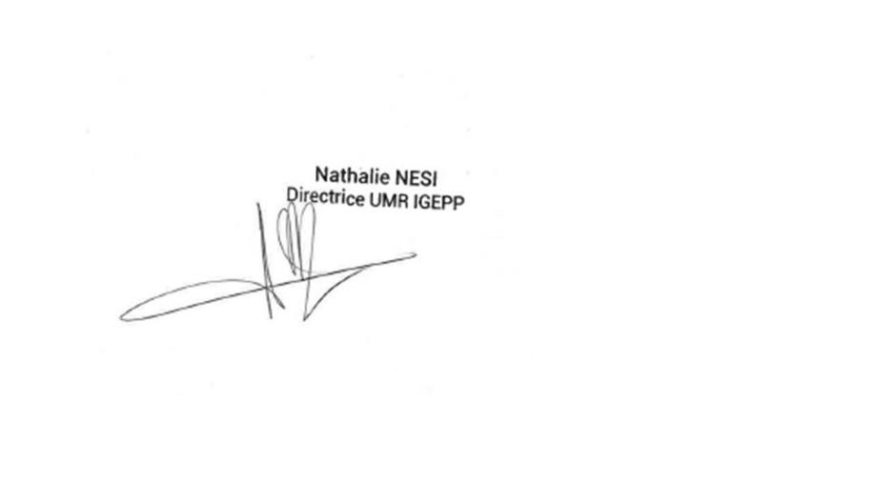

**Name, signature of team director:**

Anne Marie Cortesero

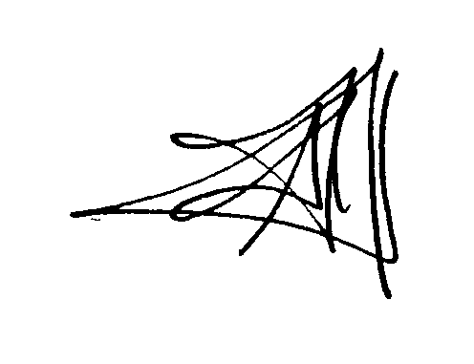

**Name, signature of thesis project director:**

Manuel PLANTEGENEST



1. **In EGAAL Doctoral School, if only one scientist in thesis supervision = 100% of supervision rate; if 2 people involved in thesis supervision = from 50% to 70% of supervision rate for the director; if 3 people involved in thesis supervision = 40% / 30% / 30% of supervision rate distribution among supervisors.**